NQW-6800 E.N.T series chairs

User & Service Manual

Nanjing Qiao Wei Medical Instruments Co.,Ltd

一、Function and use of scope
NQW-6800 ENT series chairs( the chair mentioned the later development sequel is shortened form) not only can provide for being sufferer’s chair, but also being operation table when adjust the chair’s backrest at 90。-180。 , it is the best ENT medical equipment.
二、Type specification Characteristic
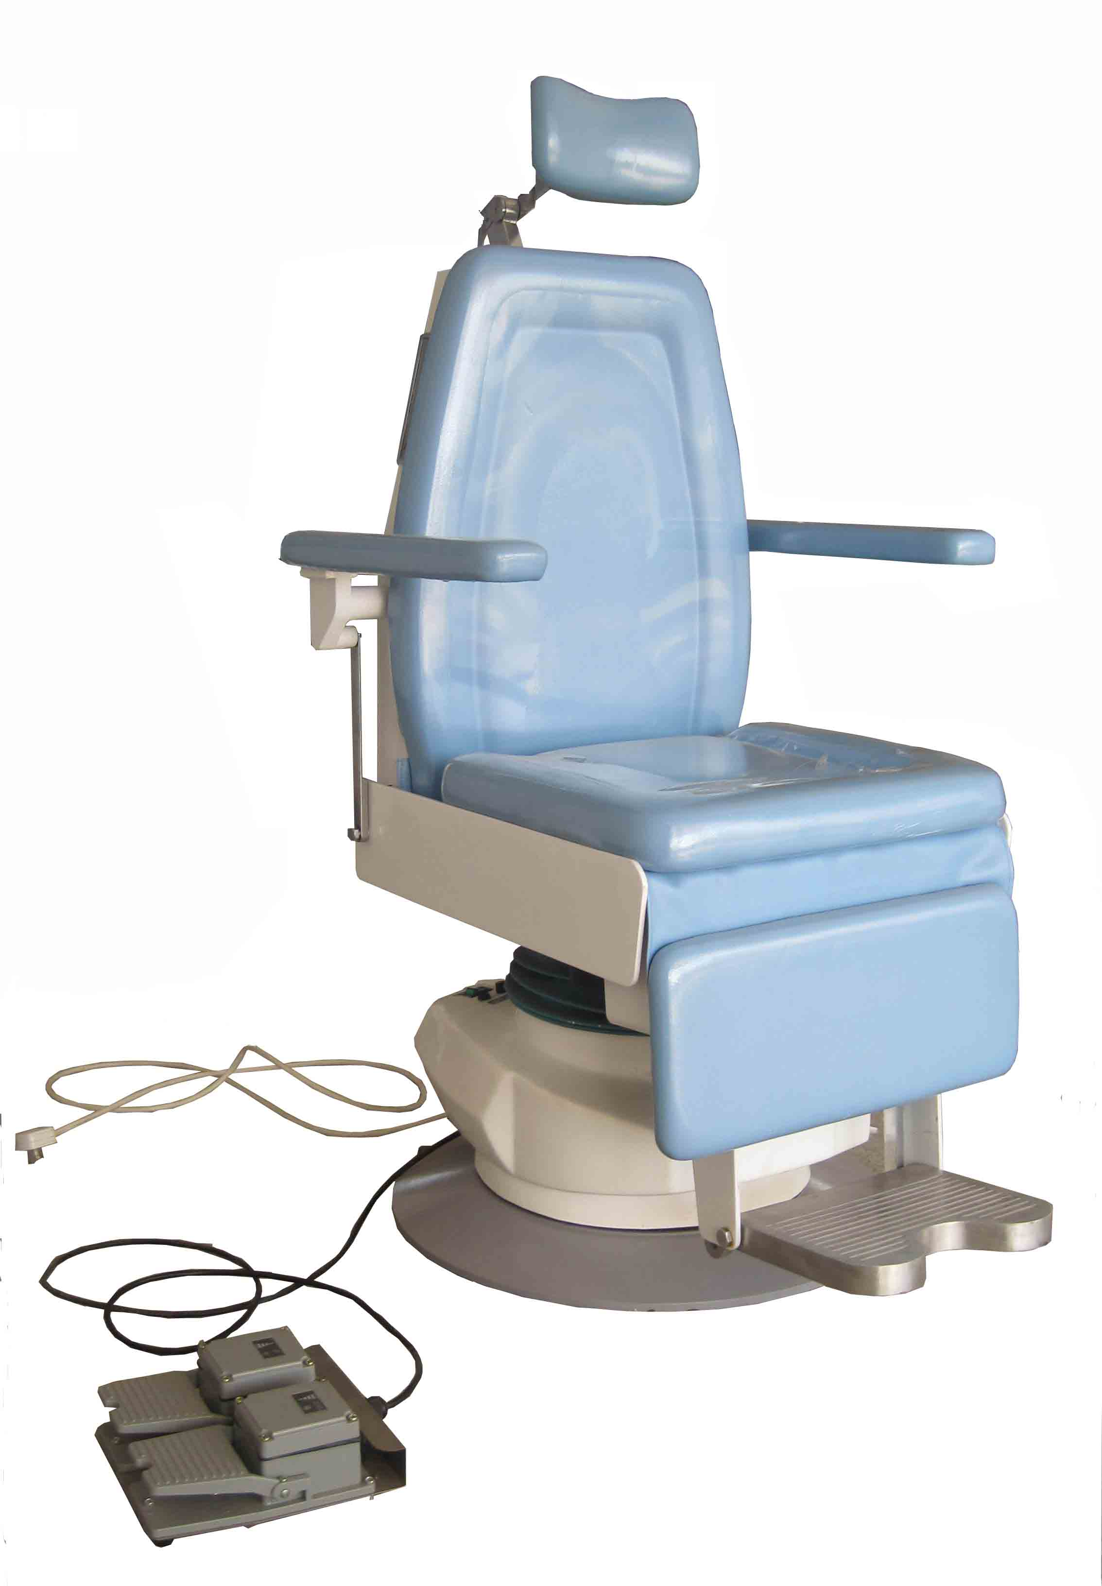
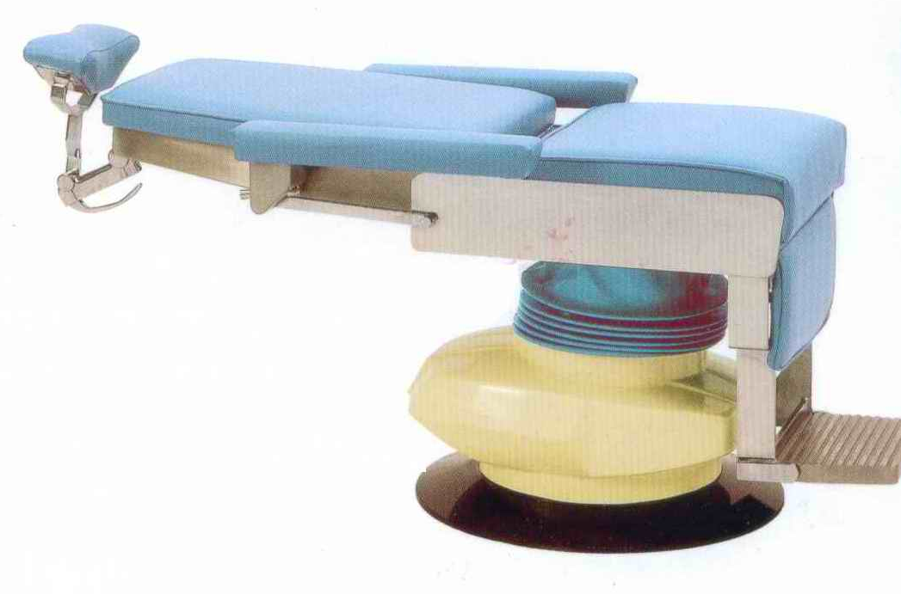

( picture 1) 6800A ( picture 2)6800C
NQW-6800, NQW-6800A. NQW-6800B and NQW-6800C are the four types of the series. Their up and down movement was controlled by electricity(As picture 1) .NQW-6800C was controlled by foot only (As picture 2).
NQW-6800, NQW-6800C chairs’ backrest making pitching movement by hand only, NQW-6800 foot pedal will not drive the backrest.(as picture 3). NQW-6800C have no foot pedal,(As picture 2).NQW-6800B chair’s backrest can’t make pitching movement.(As picture 4).

1

( picture 3) 6800 ( picture 4).6800B
NQW-6800A chair backrest making pitching movement by electricity, and foot pedal can drive up and down.(As picture 5).
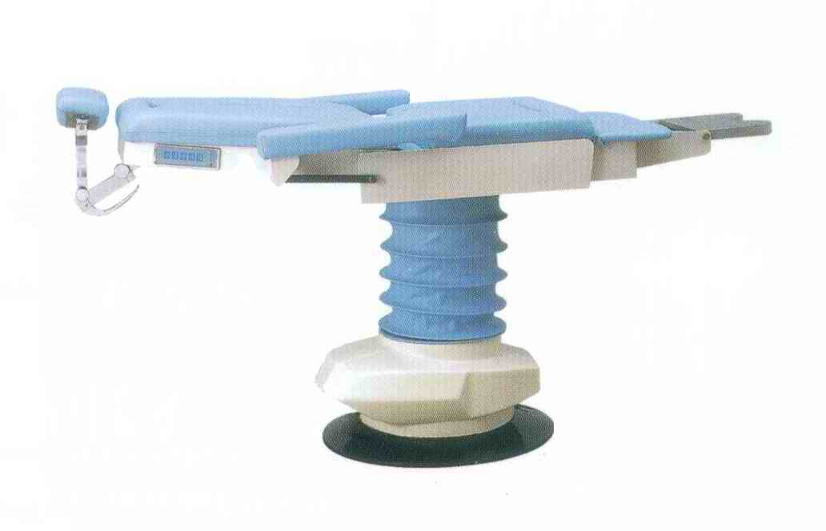

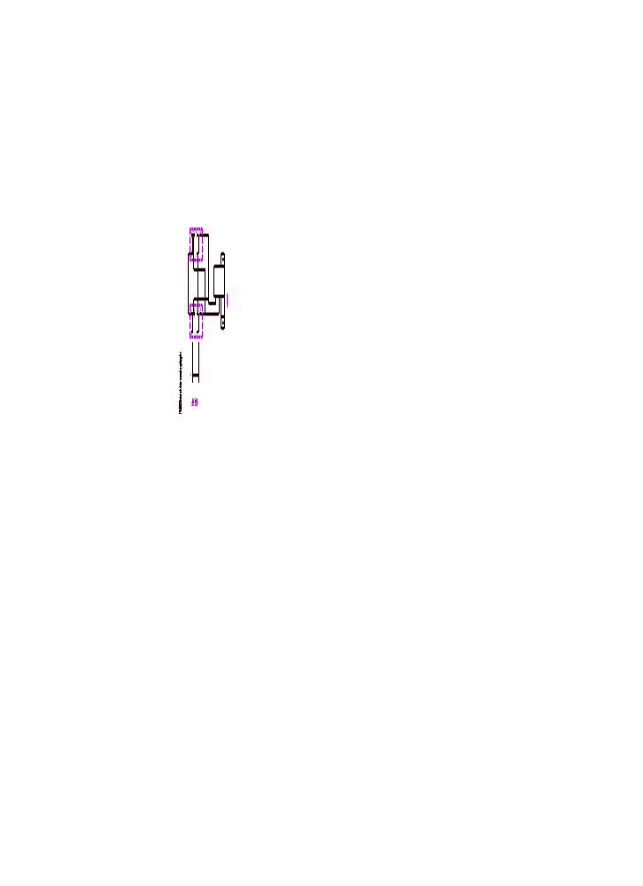
( picture 5)
NQW-6800.NQW-6800A series chairs can revolve 360⁰ when foot braking and hand pushing backrest.(as picture 6). NQW-6800B and NQW-6800C series chairs can’t revolve.

2

7
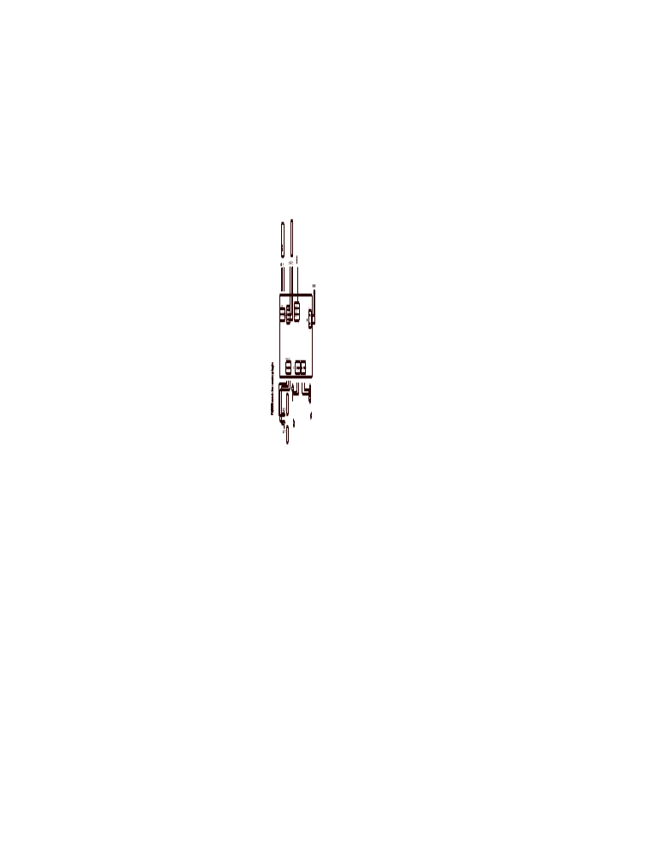

6
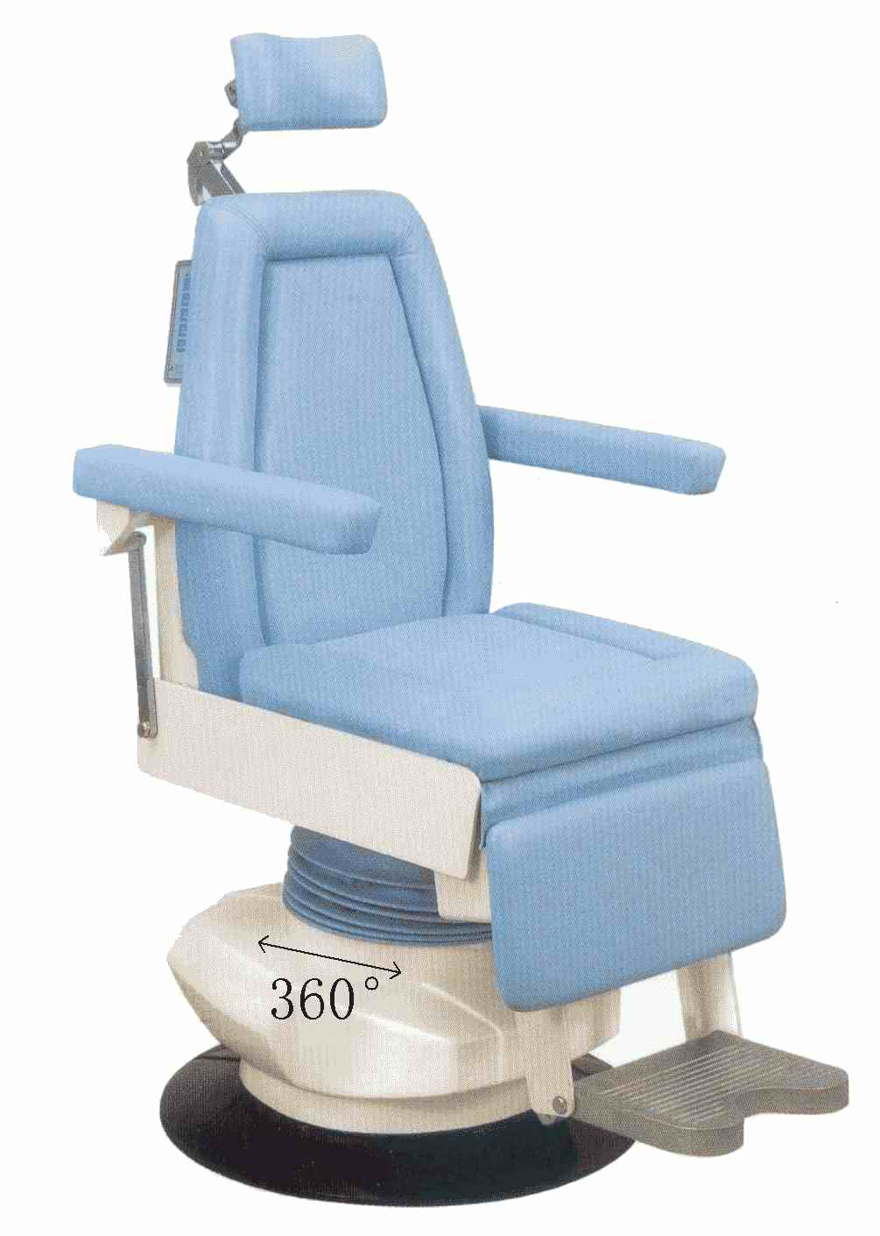

( picture 6)
三、Normal Using Condition
1.Surrounding temperature:5℃-40℃
2. Relative Humidity:≤80%
3. Air Compression:86kpa-106 kpa
4. Power: AC110V±11V
5.Fuse:5A geometry dimension:φ5×20
四． Installation and Debugging:
NQW-6800 series chairs are monolithic packed, after opening the outside packing, picking chairs out and putting it to smooth, proper installation position( far more 130cm to a wall); then placing foot switch also on flat ground, connecting to 110V power, the pilot lamp become green, now the chair have prepared for working.
五．Operation Detail
1, The height of the chair NQW-6800 NQW-6800A and NQW-6800B up and down controlled by doctor, Doctor tramples switch marked up,chair will move up; tramples switch marked down, chair will move down, There
3
is a switch on each side of NQW-6800A chair backrest, doctor can dial them by hand, NQW-6800C controlled by tramples the cylinder. The height will be limited by scale switch,(As picture 1)
2, There is a switch on each side of NQW-6800A chair backrest marked “seat F.WARD” and “ table B.WARD” both can pitch from 90⁰ to 180⁰ ,(As picture 5) to be operation table. Certainly can reinstall. (Picture 1)
3, There is a spanner in each side of NQW-6800 and NQW-6800C chair’s backrest, when clench the spanner and push down the backrest, backrest will pitching backwards gradually, and will stop as soon loosen spanner. Also can reinstall. (Picture 3)
4, There are fixes outside the basis in NQW-6800 and NQW-6800A, tramples forward, the chairs will be fixed, tramples backward and pushes any direction of backrest, the chair can revolve 360⁰, also can lock if you need to.
5, NQW-6800 and NQW-6800A chairs’ pillow adjusted conveniently in demand ( As picture 7)
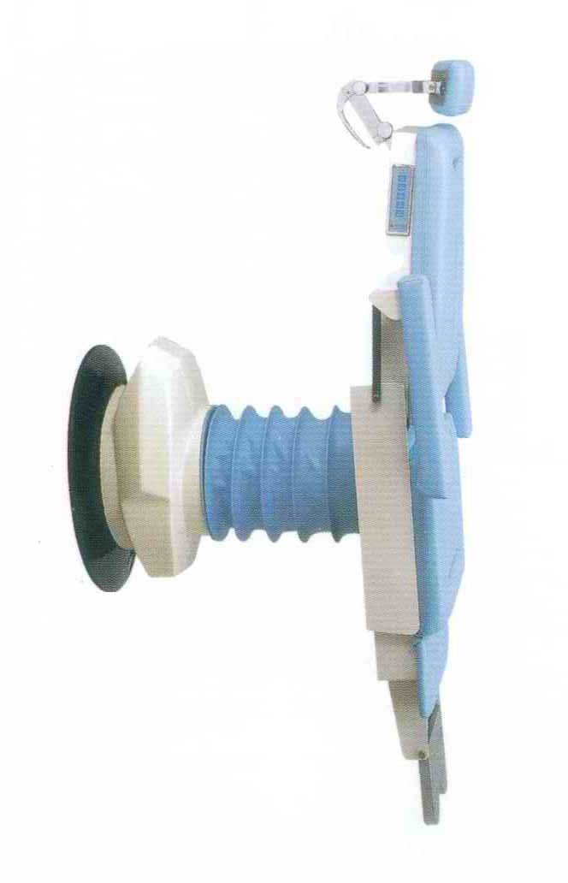
( picture 7)
6,NQW-6800. NQW-6800A and NQW-6800B series use the first electric handspike .Low noise, linear actuator, which can reduce the noise.
7.Keep the surface material cleaning, and avoid destroying it.
七．Service
Manufacture provides free charge maintenance within one year after selling.
4
Hotline:0086-25-52776778,52776779,
Fax:0086-25-52776768 Post code;211113
Address:No.7 huashang Road, Lukou industrial zone, Nanjing China.

5

